Junior Activities Handbook
2022/2023

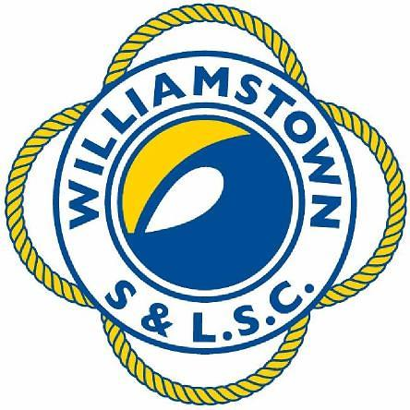
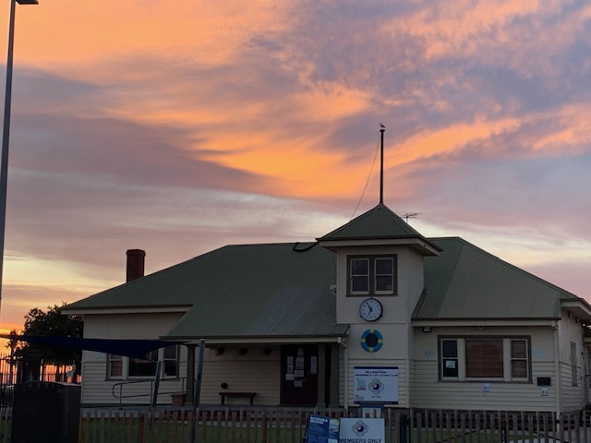
Contents
Club Contact Details 3
WS&LSC Committee 3
WS&LSC Junior Activities 3
Our Nipper Program 4
Surf Education 4
Surf Sports 5
Starfish Nippers 5
Medical conditions 6
2020/21 Nipper Program Details 7
Program Dates and Times 7
Nipper CHECKLIST …………………………………………………………………………..8
CHECKLIST - What to wear / bring ……………… 8
CHECKLIST - On the beach ………………………………………………….8
Getting Involved ………………………………………………………………………….9
COVIDSafe NIPPERs – COVID PROTOCOLS………………………………….…...10
COVID Protocols BEFORE NIPPERS ……………………………………………...11
COVID Protocols DURING NIPPERS ……………………………………………..12
COVID Protocols AFTER NIPPERS .. ……………………………………………..12
Suspected/confirmed case of COVID procedure……..………………………13
QR Code for Sign In…………………………………………………………….…………..14
Frequently Asked Questions ………………………………………………………15
Age Groups …………………………………………………………………………………16
Coloured Coded Age Group Marshalling………………………………………16
Inclement Weather or Dangerous Conditions ……………………………..17
Skills Assessment /Prelim Assessment Requirement …….………..18-19
Junior Surf Sports ……………………………………………………………………………20
Summer Carnival Events …………………………………………………………….21
Team App ……………………………………………………………………………………….22

Club Contact Details

Address: PO Box 13, Williamstown Vic Australia 3016
Club Phone: 0478 416 004
Membership Enquiries: 0418 341 595
Email: membership@williamstownslsc.org.au
Website: www.williamstownslsc.org.au
Email: juniors@williamstownslsc.org.au
Shop: merch@williamstownslsc.org.au

WS&LSC Committee
President | Claire Howell
Vice President | Leonie Newey
Secretary | Andree Parker
Treasurer | Mark Frisby
Director - Events | Sally Leung
Director – Training | Rebecca Cameron
Director – Communications | Charlie Evans
Director – Operations | Marcus Stacey
Director – Competition | Lizzie McFarlane
Director - Maintenance | Neal Coulson
Director - Junior Activities | Joel Godde

Our Nipper Program
The Williamstown Swimming & Life Saving Club’s (WS&LSC) Nipper Program aims to provide a friendly safe environment where both Nippers and Parents can increase their life saving and water safety knowledge and skills whilst having a bit of fun on the beach. This presents a great pathway to becoming a patrolling member of our Club.
Nippers commenced at Williamstown around 1996 and numbers have grown to our current average of over 300 Nippers each season.
Surf Education
Nippers aged 5-12 learn about surf awareness and safety through the national program as set out by Surf Life Saving Australia. This Surf Education program is structured specifically to Nippers’ ages and abilities and gradually teaches them basic lifesaving skills and to be safe around an ocean aquatic environment as well as developing their skills to compete in surf sports. Nippers participate in swimming, running, board paddling, wading, and other activities and games. They learn about waves, different beach types, how to identify a rip, and how to catch a wave. CPR and basic first aid are also part of the program.
Australian Surf Life Savers compete in events based on these junior skills.

Reference to the participant age at 30 September 2022 is relevant. For example, if your child turns 12 years of age prior to 30 September 2022, they will be in the U13 age group. Conversely, if a child turns 12 years of age after 30 September 2022, they will be in the U12 age group (SEE ALSO PAGE 16).
Please note: Nippers is not a ‘learn to swim’ program. There are age level swim skills that are a pre-requisite to participating in the water activities in the program.

The objectives of our Nipper Program are to:
- Develop Surf Awareness
- Increase confidence and skills in beach activities
- Instill and reinforce sun smart principles
- Offer training to those wanting to pursue competition or awards
- Progress members towards relevant surf awards
- Promote healthy and non-threatening competition
- Make new friends
- Have fun on the beach
Surf Sports
Nippers at Williamstown Swimming & Life Saving Club is a fantastic pathway to Surf Sports where our (competition) Nippers get to compete against Nippers representing Clubs throughout Victoria. Nippers from under 8 up to under 13 are eligible to participate on completion of an age specific swim skills evaluation.

https://lsv.com.au/2022-2023-lsv-aquatic-sports-carnival-calendar/

Starfish Nippers
The Starfish Nipper Program is a modified Nippers program for children with special needs, which is run in conjunction with the age group nipper program. This program caters for children and young adults from 6 years of age. The special needs spectrum includes children with Autism, Attention Deficit Disorder, Down Syndrome, Asperger’s Syndrome and physical and intellectual disabilities.
Our program caters for a diverse group of young people and makes WS&LSC one of a handful of clubs in the country that has adopted this amazing initiative. The program includes beach games, beach flags, water familiarisation and surf safety.
Volunteers are needed to assist with running and managing water safety. If you have any questions or are interested in helping please email juniors@williamstownslsc.org.au
Medical Conditions
WS&LSC promotes an inclusive environment and welcomes all participants. We will endeavor to work to provide an appropriate program to all wishing to participate in Nippers. Please notify the director of Junior Activities of any medical conditions or special needs on renewal of membership.

2022/23 Nipper Program Details
Program Dates
The WSLSC Nippers program for 2022/23 will be held on the following Sundays:
NIPPER PROGRAM DATES
Session #1 13 November 2022
Session #2 20 November 2022
Session #3 27 November 2022
Session #4 4 December 2022
Session #5 11 December 2022

Session #6 18 December 2022
Session #7 22 January 2023
Session #8 29 January 2023
Session #9 5 February 2023
Session #10 12 February 2023

Session #11 19 February 2023

Session #12 26 February 2023

Note: All sessions are subject to weather conditions and COVID restrictions at the time.
Closing date for Nippers applications is 28 October 2022

Program Times
WS&SLC provides the following options for your children:
9.00am to 10.00am
For U6-U13 Nippers who have obtained their Preliminary Swim Assessment.
Nipper CHECKLIST

CHECKLIST - What to wear / bring
It is important your Nipper is well prepared for a session at the beach and should wear:
- Bathers
- A rashie / wetsuit (if cold)
- Broad brimmed hat
- Sunscreen (applied prior to the session)
- Nipper cap (provided at sign on from Age Manager)

Nippers should also bring:
- Water bottle
- Goggles
- Towel
Please clearly label every item with your child’s name. There are literally bucketloads of lost property at the end of every season! If you have lost something – please check the lost property basket – located on the club steps.

CHECKLIST - On the Beach
- Arrive at least 15 minutes prior to the session start time
- Find your Nipper’s age group flag on the beach
- Parents Use the QR Code to sign in (see page 14) which will be with your Age Manager at your activity zone on the beach
- Nippers need to sign the attendance lists which will be with your Age Manager
- After signing in, you’ll receive a coloured age group cap from the basket
- At the session’s end, return your age group cap to the basket
- For safety, any Nipper in U6, U7 or U8 age groups needs to be accompanied by an adult to and from the toilet. Please notify the Age Group Manager if you leave the session. Older age groups need to go with a buddy or an adult.
Getting Involved
Parent involvement is vital for the operational success of the Nippers program. The entire program is resourced solely by volunteers. Every person turning a snag, assisting with water safety or running sessions as an Age Manager is a parent or club volunteer!

It is easy being an active parent in the program. The many ways that you can assist are:
- Beach Sweep prior to the session
- Beach Set Up & Pack Up
- Assisting with beach activities
- Rinsing down the boards after the session
- Age Managing (small amount of training req.)
- Water Safety (Bronze Medallion req.)

NB** Water Safety - As a requirement of SLSA & LSV (our governing bodies) we MUST have adequate Water Safety at ALL sanctioned WSLSC training and competition events throughout the season. Without adequate water safety for each session, we will be forced to restrict the numbers of Nippers in the water at any point
in time. This is a non-negotiable SLSA, LSV & TSLSC safety requirement that will be strictly adhered to – always!

If you are interested in assisting or getting trained up for a role, please contact us at: juniors@williamstownslsc.org.au
You will have access to people and processes to help guide you in your roles to make it easy!
Remember: Kids love to see their parents engage and have an active role in the things they do!

COVIDSafe Nippers – COVID protocols

The following protocols have been adopted by WS&LSC to mitigate the COVID risks and comply with the various guidelines and will be relevant to the Nippers Program this year.

Parents/carers of Williamstown S&LSC Nippers in 2022/23 need to:

- Adhere to Club COVID policies and Victorian State Government and Life Saving Victoria guidelines and review the parent checklist each session
- Sign in each session for each parent (and each nipper) using the WS&LSC COVID Comply QR code
- Maintain social distancing at the beach (1.5m apart)
- Ensure you have downloaded the Team App to ensure you receive all relevant announcements

Please also note:
- Nippers activities will be modified to minimise contact
- Without volunteers in all roles, it is likely we will not be able to offer a program for some age groups
- Parents will need to be flexible as the program may need to be further modified to deal with Government restrictions
- There is a risk that Nippers sessions may be cancelled if restrictions increase; and
- The primary communication channel is via Team App – session information, notifications of program changes and general announcements will be made via Team App.

COVID Protocols: BEFORE NIPPERS
- Personal Health checklist (self-assessment / RAT before attendance)
- Each parent must sign in (and sign in each nipper) using the WS&LSC COVID Comply QR code
- Social distancing of 1.5 metres between persons (including parents/carers/spectators and nippers, where possible) is required across the beach
- Session times for Nippers will run for 1 hour, commencing at 9am
- ‘Zones’ will be created for Nippers (as per Beach Set up map) to undertake activities safely and separate areas for parents/spectators to ensure at least 4sqm per person in each age-group zone (with Under 12/13 to be combined)
- Water safety volunteers will be assigned a role prior to each session and cannot move between age groups
- Volunteers will be appointed to set up (as per beach set up plan) and pack up equipment
- Parents will be asked to comply with the LSV Nipper & Parent/Carer Checklist before, during and after each session
- One parent in each age group will be appointed to monitor compliance with COVID protocols
- Maintenance of personal hygiene to include:
  - Hand sanitiser: provided at the entrance door for use by every individual entering the board shed
  - Disinfectant: wipes provided to clean high contact surfaces
- Other considerations: – any equipment being utilised in the board shed will be disinfected before and after use. All equipment to be used by ONE person only – where equipment is not allocated to an individual (i.e. ‘shared’) the equipment must be disinfected prior to use by another individual (the original user and the subsequent users are responsible to ensure this occurs)
- Age Group Managers/Leaders will be provided with a copy of LSV’s Checklist and Modified Skills guide
- Please limit the number of people in the board shed (due to the limited open space available within the shed when full of equipment)
  - Buckets with disinfectant and sponges will be made available to enable equipment to be washed down outdoors for each age group
  - Board Wranglers/equipment managers must ensure boards have been properly cleaned after each use

COVID Protocols: DURING NIPPERS
- Parents will not be permitted to enter the Nipper zones unless they have a pre-allocated volunteer role
- Nippers are to stay within their allocated age groups for the session - minimising any risk of interacting with other age groups
- Parents will be asked to comply with the LSV Nipper & Parent/Carer Checklist before, during and after each session
- Nippers will only be able to use boards as per the Nippers Program. Board Wranglers/Equipment managers must ensure boards have been properly cleaned after each use
- One parent in each age group will be appointed to monitor compliance with COVID protocols
- Social distancing of 1.5 metres between persons (including parents/carers/spectators and nippers, where possible) is required across the beach

COVID Protocols: AFTER NIPPERS
- On return of equipment, the clean would ideally be conducted outdoors to reduce the number of people within the board shed
- Social distancing of 1.5 metres between persons (including parents/carers/spectators and nippers, where possible) is required across the beach
- Volunteers will be appointed to set up and pack up equipment
- Parents will be asked to comply with the LSV Nipper & Parent/Carer Checklist before, during and after each session
- Any concerns are to be raised with the Junior Coordinator and will be discussed with the COVIDSafe Officers
- There will be no all-group briefings or post-nippers catering

QR Code for Sign In

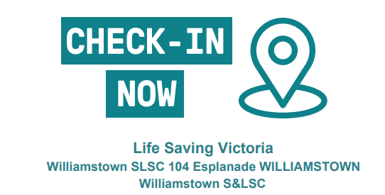
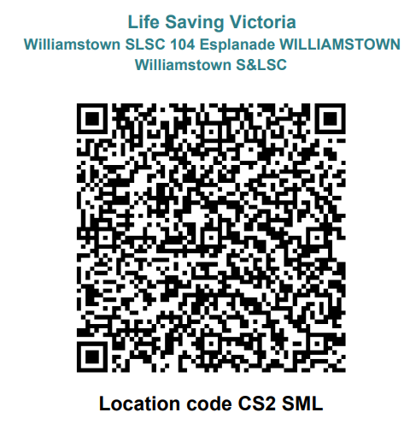

Frequently Asked Questions
- Will my Nipper ‘Learn to Swim’ during the sessions? Nippers is not a ‘learn to swim’ program and your child will be required to complete a Preliminary Assessment to ensure they are able to complete required water activities safely. We strongly encourage all parents of children with limited swimming ability to enrol their child in swimming lessons first.
- Does each parent require a Working with Children’s Check? Yes, any member over 18 years must have a valid Working with Children’s Check before their membership can be approved (Teachers will also need to obtain a WWCC). Further information can be found at 'LSV Working with Children Check FAQs'
- Can I ‘drop and run’? Absolutely not. Nippers is not a ‘drop and run’ program and we need parental support and involvement. You must stay close to the beach. Parents of U6’s, U7’s and U8’s must able to see your Nipper during the entire session.
- What if there is bad weather and/or dangerous conditions? The Nipper Program will proceed where reasonable. A few spits of rain and wind won’t deter us, but when it is not safe the program will be cancelled (Parents/carers will be notified via Team App).
- Do we have to join as a family? Any Nipper at WS&LSC must be a member of a Family Membership.
- What will my child do at Nippers? Your child will learn about surf awareness and safety and participate in board paddling, swimming, beach running, wading, flags and First Aid.

Age Groups
All Nippers are grouped according to age and for the 2022/23 season as follows:
Date of birth | Nippers Age Group
1 October 2016 to 30 September 2017 | U6
1 October 2015 to 30 September 2016 | U7
1 October 2014 to 30 September 2015 | U8
1 October 2013 to 30 September 2014 | U9
1 October 2012 to 30 September 2013 | U10
1 October 2011 to 30 September 2012 | U11
1 October 2010 to 30 September 2011 | U12
1 October 2009 to 30 September 2010 | U13

Colour Coded Age Group Marshalling
Each age group has a designated coloured age banner and age group caps:
UNDER 6 | PINK
UNDER 7 | ORANGE
UNDER 8 | RED
UNDER 9 | PURPLE
UNDER 10 | YELLOW
UNDER 11 | WHITE
UNDER 12 | BLUE
UNDER 13 | GREEN

Inclement Weather or Dangerous Conditions
The Nipper program will proceed even if conditions aren’t that great, however the activities will be modified to ensure the safe participation of all members.
In the event conditions cannot be worked around – the session will be cancelled. We will aim to notify members as early as possible via Team App.

Dangerous Conditions include:

- Strong Winds
- Rough or dangerous water conditions
- Poor water quality
- Extreme Temperatures
- Electrical Storms

Skills Assessment
In order to ensure Nippers in the Surf Education program have a suitable swimming ability for them to safely participate in water activities, Surf Life Saving Australia has formulated preliminary assessment requirements for each age group.
If your Nipper would like to represent WS&LSC and compete in LSV Surf Carnivals they will need to pass the Competition Skills Evaluation criteria (or S Badge).

We strongly recommend that children with limited swimming ability be enrolled in swimming lessons prior to joining. Nippers is not a ‘learn to swim’ program.

If your Nipper attends swimming lessons, the assessment form can be downloaded from our Website, (under Nippers) and signed off by their swimming instructor.

PLEASE NOTE: Nippers who have not completed their prelim swim assessments are not permitted to participate in water activities.

Please forward the completed form to juniors@williamstownslsc.org.au

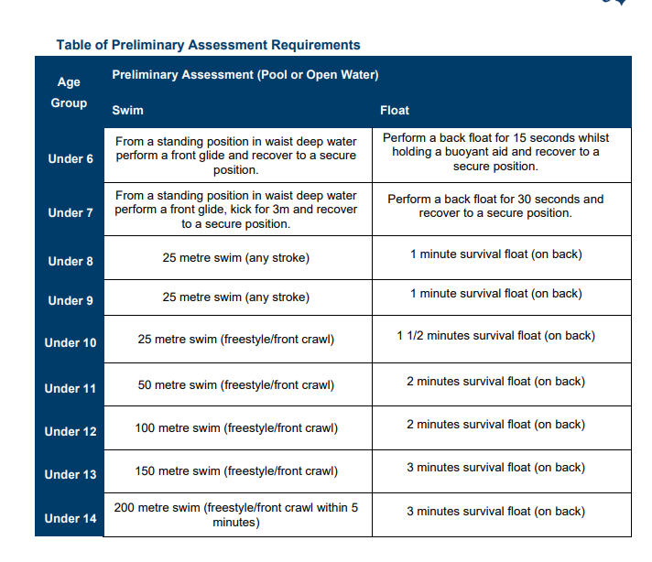
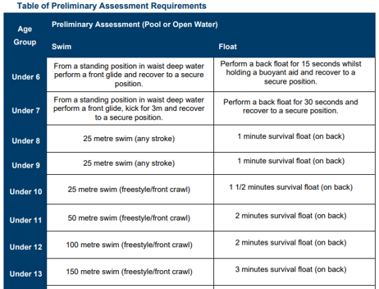
Junior Surf Sports
Junior Surf Sports is an extension of the Nippers Surf Ed program which keeps our Nippers involved in life saving and promotes an active lifestyle and healthy competition.
Any Williamstown Nipper U8-U13 is welcome to join the WS&LSC competition team, where our Nippers get to compete against other Nippers representing clubs throughout Victoria.

These competitions are conducted at Interclub Carnivals at various beaches in Victoria across the bay and Surf Coast. These carnivals are well supported by Nipper communities around Victoria and can be a colourful and impressive spectacle.

The LSV Aquatic sports carnival calendar can be found here:
https://lsv.com.au/2021-2022-lsv-aquatic-sports-carnival-calendar/
A Carnival entry fee is applicable per carnival. The fee must be paid to the Club prior to each carnival and can be made via the store on the Team App. This fee is passed on wholly to Life Saving Victoria.
All Surf Sports Nippers are required to complete an age-specific swim skills evaluation (this is an addition to the Preliminary Swim Assessment) The club will schedule assessments early in the season.

If you are interested in joining the competition team, please email comp@williamstownslsc.org.au to find out more!

Summer Carnival Events
Junior Nipper Carnivals offer both team and individual events in the open water and on the sand.

INDIVIDUAL EVENTS | TEAM EVENTS
Surf Race | Surf Teams
Wading Race | Wade Relay
Surf Board Race | Beach Relay
Ironman | Board Rescue
Ironwoman | Aqua Cameron
Beach sprint | 2 person Rescue & Resuscitation
Beach Flags | Belt & Reel

Team App
WS&LSCs’ primary method of communication with our Members is via Team App.
It is important that you sign up to and familiarize yourselves with WS&LSCs’ Team App. The Club will inform Nippers’ families of any news, special events, documents, newsletters and any change in the program (especially ‘on the day’ notices due to bad weather) via Team App.
WS&LSC Team App is a closed app to the public. Only members (who have been approved by WS&LSC) can access the App’s information.
To get the Team App on your smartphone download from the App Store or Google Play and either sign in (new members) or log in (existing account). You can also access on your desktop at www.teamapp.com
If you have any issues with Team App please refer to the FAQs https://www.teamapp.com/faqs
Please search for ‘WSLSC’ and request access to Nippers and Member. For Nippers who compete for WS&LSC please search for ‘WSLSC Competition’ and request access to Junior Comp.
